Module 4: Group Products

Lesson 1: Group Insurance

Learning Objectives

After studying this lesson, you will be able to:
- Identify the parties to a group insurance contract.
- Identify the requirements the parties must meet to form a valid group insurance contract.
- Describe the purpose of a certificate of insurance.
- Distinguish between contributory and noncontributory group insurance plans.
- Contrast insurer-administered plans with self-administered plans.
- Identify the factors used to underwrite group insurance contracts.

The Group Insurance Contract

Learning Objective
Identify the parties to a group insurance contract.
Identify the requirements the parties must meet to form a valid group insurance contract.
Open Transcript
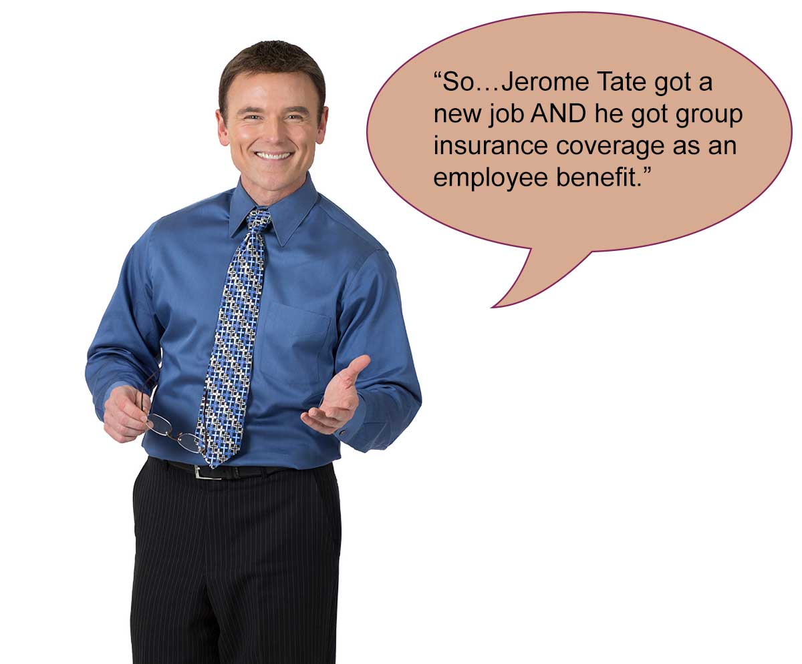

Group Insurance Basics

Individual insurance products insure one person or a single family. Group insurance insures the members of a group (such as the employees of The Stetson Company) under one contract—the master group insurance contract.
Many different types of insurance can be issued as group insurance.
For example, The Stetson Company provides its employees with group life insurance, medical expense insurance, disability insurance, and dental insurance coverage.
For now, we’ll use Stetson’s group life insurance policy to show how group insurance works. Many of the principles are similar for other group insurance products. We’ll start with some basic terms.

Jerome Tate is insured by the Stetson Company's group policy and is known as a group insured.

Able Life Insurance Company issued the group policy to the Stetson Company and will pay a benefit following the death of any group insured.

The Stetson Company is known as the group policyholder.

Which of these people or companies is a party to the group insurance contract? (Choose all that apply.)
^{Jerome Tate}
^{Able Life Insurance}
^{The Stetson Company}
Submit

Requirements for a Valid Contract

Remember the requirements for a valid contract?
- The parties to the contract must mutually agree to the contract’s terms
- The parties must have contractual capacity
- The parties must exchange legally adequate consideration
- The parties must enter into the contract for a lawful purpose

Do you think Able Life and The Stetson Company (the parties to the group insurance contract) have to meet these same four basic requirements?
Yes, the requirements generally are the same.
No, the requirements are different.

Lawful Purpose

Individual insurance contracts meet the lawful purpose requirement when insurable interest is present. In other words, if the policyowner or beneficiary will suffer a genuine loss if the insured dies, the contract isn’t a wagering agreement and is lawful.
Group insurance contracts have no insurable interest requirement.
Instead, a group contract meets the lawful purpose requirement because the policyholder buys the coverage for others and is unlikely to benefit from the death of the insureds. As a result, the group policyholder’s interest in the contract doesn’t present the same risk of creating a wagering agreement.

Jerome is covered by the group life insurance plan issued by Able Life. This means that Jerome is a group
^{Policyholder}
^{Insured}
Is Jerome a party to the group insurance contract?
^{Yes}
^{No}
Was The Stetson Company required to have an insurable interest in the lives of participating employees?
^{Yes}
^{No}

Ownership and Group Insurance Plans

Learning Objective
Describe the purpose of a certificate of insurance.
Distinguish between contributory and noncontributory group insurance plans.

Ownership Rights
As the policyholder, The Stetson Company has some ownership rights in the policy. But it doesn’t have as many rights as the owner of an individual insurance policy.
Some ownership rights belong to the group insureds. For example, they each have the right to name the beneficiary of their coverage.
Open Transcript

Certificate of Insurance

A group insured doesn’t get a copy of the master group insurance contract. Instead, the group insured gets a certificate of insurance.
Jerome can find out all about his Able life insurance coverage by reading the certificate of insurance that The Stetson Company will give him once he is officially covered.

Premium Payments

To keep the group coverage in force, a policyholder is responsible for sending premium payments to the insurer. But group insureds may be required to pay part of the premiums.

The Stetson Company’s plan is a noncontributory plan. What does this mean?
Jerome must pay some or all of the premium for his coverage.
Stetson pays the entire premium for Jerome’s coverage.
Jerome and Stetson equally split the premium for Jerome’s coverage.
Can you guess the name of a plan that does require insured group members to pay some part of the premiums?

Contributory Plan
Unlike its group life insurance plan, Stetson’s group medical expense plan is a contributory plan.
Stetson pays a portion of the premium, and the group insureds pay the rest.


The Accent Company, an employer, has a group life insurance plan that insures the lives of eligible employees. Accent pays the entire premium for the coverage. Check all the statements that are true for this situation.
Accent’s group life insurance plan is a noncontributory plan
Accent must provide employees with a copy of the master contract
Accent must name the beneficiary of the coverage

Ownership and Group Insurance Plans

Learning Objective
Describe the purpose of a certificate of insurance.
Distinguish between contributory and noncontributory group insurance plans.

Ownership Rights
As the policyholder, The Stetson Company has some ownership rights in the policy. But it doesn’t have as many rights as the owner of an individual insurance policy.
Some ownership rights belong to the group insureds. For example, they each have the right to name the beneficiary of their coverage.
Open Transcript

Certificate of Insurance

A group insured doesn’t get a copy of the master group insurance contract. Instead, the group insured gets a certificate of insurance.
Jerome can find out all about his Able life insurance coverage by reading the certificate of insurance that The Stetson Company will give him once he is officially covered.

Premium Payments

To keep the group coverage in force, a policyholder is responsible for sending premium payments to the insurer. But group insureds may be required to pay part of the premiums.

The Stetson Company’s plan is a noncontributory plan. What does this mean?
Jerome must pay some or all of the premium for his coverage.
Stetson pays the entire premium for Jerome’s coverage.
Jerome and Stetson equally split the premium for Jerome’s coverage.
Can you guess the name of a plan that does require insured group members to pay some part of the premiums?

Contributory Plan
Unlike its group life insurance plan, Stetson’s group medical expense plan is a contributory plan.
Stetson pays a portion of the premium, and the group insureds pay the rest.


The Accent Company, an employer, has a group life insurance plan that insures the lives of eligible employees. Accent pays the entire premium for the coverage. Check all the statements that are true for this situation.
Accent’s group life insurance plan is a noncontributory plan
Accent must provide employees with a copy of the master contract
Accent must name the beneficiary of the coverage

Group Insurance Characteristics

Learning Objective
Contrast insurer-administered plans with self-administered plans.
Group insurance can insure a number of people at a relatively low cost compared to the cost of insuring the same number of people with individual policies. The lower cost is possible because group insurance provides expense savings in the following three areas:
- Sales
- Underwriting and policy issue
- Policy administration

Sales
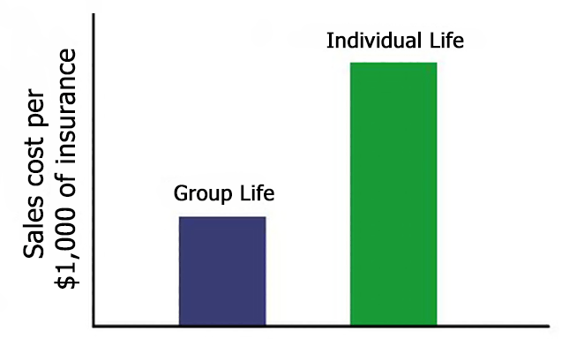
An insurer pays a sales commission for each individual life policy it issues.
A single group insurance policy covers many people, so its sales costs per $1,000 of life insurance are less than for individual policies.

Underwriting and Policy Issue

Group underwriting costs are lower because the insurer evaluates the risk characteristics of the group as a whole—not the risk presented by each group member.
One exception is for very small groups. For these, underwriters will evaluate group members individually.
Policy issue costs are lower because the insurer issues one master policy rather than many individual policies.

Group Policy Administration

Group plan administration is mostly recordkeeping. Group life insurance requires current information about
- The name of each group insured
- The amount of coverage for each group insured
- The name of each group insured’s beneficiary
The group policyholder often collects and manages this information for the insurer; whereas the insurer has to perform such tasks for individual insurance policies.
The more administrative duties the group policyholder handles, the lower the group insurer’s administrative expenses.

We can categorize group insurance plans according to whether the insurer or the group plan handles administrative and recordkeeping activities. The Stetson Company keeps the records of each group insured and handles other administrative duties. This means that Stetson’s group life plan is
^{An insurer-administered plan}
^{A self-administered plan}
When The Stetson Company applied for the group life insurance policy, Able Life’s group underwriters evaluated the application before issuing the policy. Did Able Life require each Stetson employee to provide evidence of insurability?
^{Definitely yes}
^{Probably not}

Group Insurance Underwriting

Learning Objective
Identify the factors used to underwrite group insurance contracts.
Individual underwriters and group underwriters ask the same basic questions:
- Does the proposed insured—whether an individual or a group—present an average risk? A greater-than-average risk? A less-than-average risk?
- Can the insurer estimate the future loss experience?
- Is that potential loss experience acceptable to the insurer?

Which underwriting objectives are common to both group and individual underwriting? Choose all that apply.
^{Prevent antiselection}
Keep administrative costs for the coverage as low as possible
Assign a risk classification to the proposed insured individual or group
Charge the appropriate premium rate(s)
Submit

Group Underwriting Guidelines
Each group insurer establishes its own underwriting guidelines. Following those guidelines, the group underwriter evaluates specific characteristics of the group to see if it is an acceptable risk.
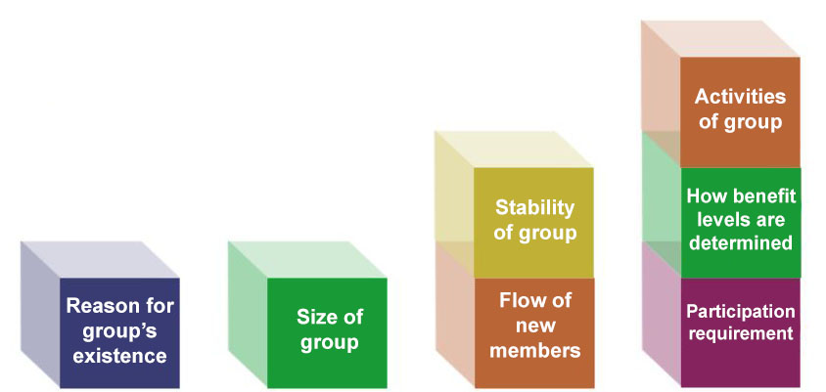
In the following sections, you’re going to help Dale, a new group underwriter at Able Life, understand group underwriting characteristics.


Reason for a group's existence
Not every type of group is insurable. The reason for a group’s existence helps group underwriters determine whether or not a group is eligible for insurance.

Let’s Help Dale
Help Dale evaluate several different groups for group insurance coverage. Select each eligible group based on the reason for the group’s existence. Choose all that apply.
The full-time employees of the Carlyle Corporation
Workers who are members of the Woodworkers Union of America
Workers who are members of either the Woodworkers Union of America or the Electrical Workers Union
Ten friends who formed their own club to get a group insurance policy
People who are members of a national association of engineers
People who have borrowed money from the Blue Street Bank
The members of the Cooperative Credit Union
Submit



Group Underwriting Guideline

Why do you think insurers won’t insure groups that were formed solely to buy insurance coverage? (Click or touch the tab below.)
Answer

Groups Typically Eligible for Group Insurance
The following groups are typically eligible based on their reasons for existence:
- A single-employer group that includes employees of a single employer. This is the most common type of insured group.
- A group that consists of the members of a labor union.
- A multiple employer group that consists of employees of two or more employers or labor unions.
- An association group that consists of people who share a common bond, such as being in the same profession or being alumni of the same university.
- A debtor-creditor group that consists of people who have borrowed from a lending institution.
- A credit union group that consists of the members of one or more credit unions.

Size of the Group
The size of the group affects the underwriting process.

Let’s Help Dale
So, if Dale is evaluating two groups:

Group A, a small business that has 25 employees

Group B, a large business that has 500 employees

Which group is likely to have the better loss rate?
^{Group A}
^{Group B}
Cannot tell from this information

I’ve forgotten what a loss rate is
Before we go any further, do you recall what a loss rate is?
The loss rate is the probable rate of loss that a group of insured people will experience. To calculate the loss rate for a group, an insurer estimates the number and timing of covered losses that will occur.
The insurer uses the estimated loss rates to set premium rates that will be adequate to pay claims for covered losses.
For which group will Dale be able to more accurately predict the loss rate?
Group A—the small business with 25 employees
Group B—the large company with 500 employees
He can predict both with equal accuracy

Underwriting Small Groups
Some insurers set a minimum group size—for example, the group must have at least 50 members to qualify for coverage.
Insurers issuing coverage to very small groups may modify their underwriting processes as follows:
Examples:
Group Size |  | Underwriting Approach
Fewer than 15 members |  | Each member provides evidence of insurability
15 to 50 members |  | Insurer pools together several small groups with similar job duties to estimate the loss rate

Flow of New Members
Does the flow of new members into a group affect the group's risk characteristics? You bet.

Let’s Help Dale
Dale is now evaluating an application from a group of retired people. Membership in the group is closed and no new people will be joining the group. Is the group insurable?
^{Yes}
^{No}

Imagine a group with no inflow of new members.
(click or touch the arrows to the right)

Stability of the Group
A steady flow of new members is necessary, but the stability of the group also is important.

Let’s Help Dale
Dale is evaluating three more groups. Help him determine which ones are likely to be insurable. Choose all that apply.
A group that will exist for only 18 months
^{A group of seasonal workers}
^{A group of temporary workers}
^{None of these}
Submit

Participation Requirement
Group insurance underwriting guidelines require plans to cover at least a minimum percentage of eligible group members.
The specific participation requirement depends on whether the plan is contributory or noncontributory. When a plan is noncontributory (the policyholder pays 100% of premium), 100% of eligible group members MUST BE covered. If all eligible group members aren’t covered, the plan would be unfair to the group members who aren’t covered.

Let’s Help Dale

Dale is evaluating an application from an employer that wants to provide a contributory group insurance plan for its employees.
Help Dale determine what percentage of eligible employees this plan must cover.
^{All eligible employees}
At least 75% of eligible employees
At least 30% of eligible employees

Employees who believe themselves to be in good health sometimes choose not to participate in a group insurance plan. Having too few participating employees means that those who DID sign up are more likely to be in poor health. That’s antiselection.
If more employees sign up, there are more likely to be enough good risks (and enough in premiums!) to balance things out.

How Benefits Are Determined
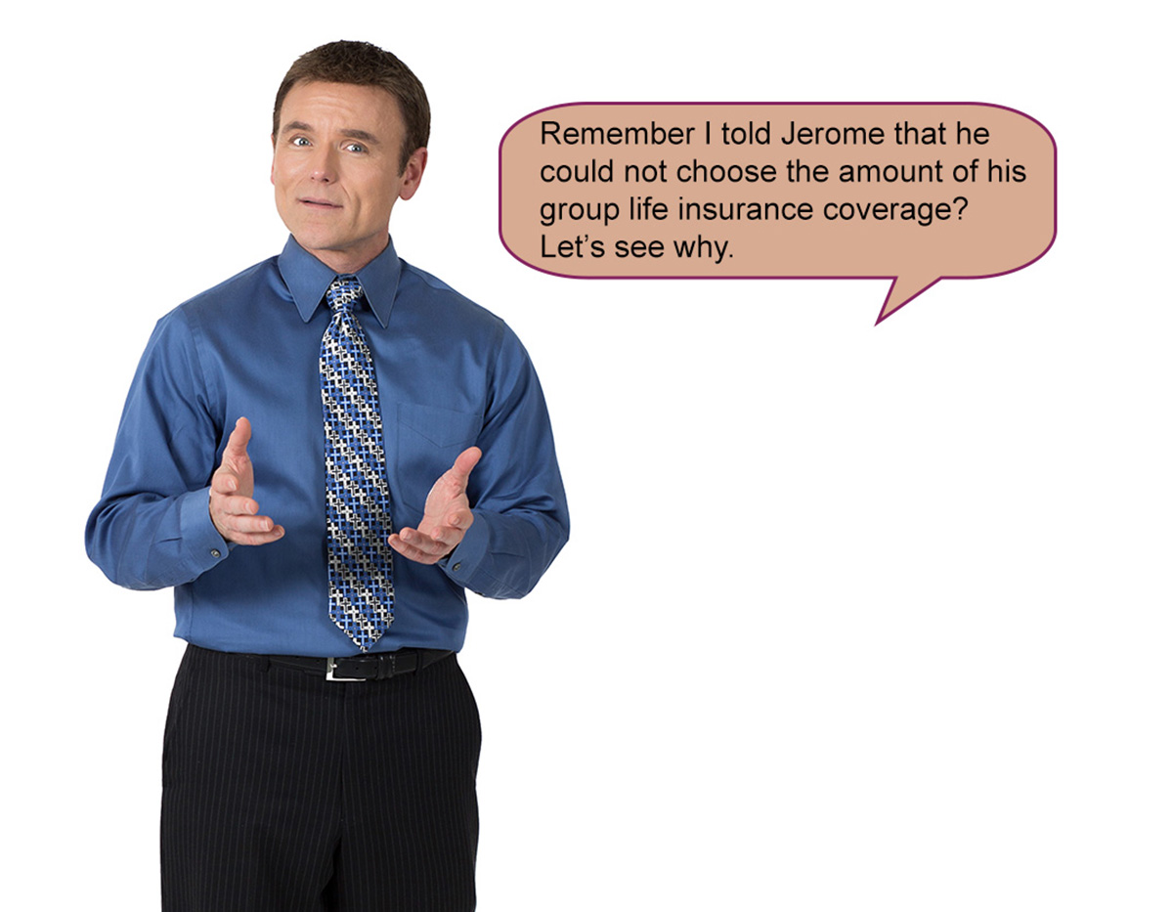
Image Description

Let’s Help Dale
Why won’t insurers allow group insureds to choose the amount of their group coverage?
People in poor health are likely to select larger benefit amounts than people in good health.
People in good health are likely to select larger benefit amounts than people in poor health.
Laws require the policyholder to set benefit amounts.
Laws require the insurer to set benefit amounts.

To prevent such antiselection, the insurer and the group policyholder work together to set a fair method of determining the benefit levels that group members will be eligible for.
Often benefit amounts vary according to salary, job classification, or length of employment. For example, a benefit schedule may provide a life insurance benefit equal to one year of an employee’s salary.
The master group insurance contract describes those benefit levels.

Activities of the Group

Let’s Help Dale
Dale’s evaluating these group life applicants:

He must assign each group to a risk classification (standard, substandard, or declined). Is Dale likely to assign the three groups to the same risk classification?
- A group of architects
- A group of teachers
- A group of coal miners
^{Yes}
^{No}

Good job helping Dale underwrite this group. Now let’s review what you’ve learned.

Let’s compare individual to group life insurance. Select the response that applies to individual policies only, group policies only, or both individual and group policies.

The insured person is a party to the contract.
^{Individual}
^{Group}
^{Both}
The parties to the contract must have contractual capacity.
^{Individual}
^{Group}
^{Both}
The parties to the contract must mutually agree to the contract.
^{Individual}
^{Group}
^{Both}
The policyowner must have an insurable interest in the life of the insured.
^{Individual}
^{Group}
^{Both}
Underwriting focuses on the characteristics of individuals.
^{Individual}
^{Group}
^{Both}
A primary underwriting objective is to prevent antiselection.
^{Individual}
^{Group}
^{Both}
The insured, rather than the policyholder, names the beneficiary.
^{Individual}
^{Group}
^{Both}
Underwriting looks at potential administrative costs associated with the contract.
^{Individual}
^{Group}
^{Both}
Underwriting assigns a risk class and sets an appropriate premium rate.
^{Individual}
^{Group}
^{Both}
Able Life received group life insurance applications from the following groups. Select the group(s) that Able would consider insurable.
The Oaktree Company seeks to cover its 100 employees
The Wigwam Company seeks to cover its 1,000 employees
The Dahlia Club, a group formed for the purpose of obtaining insurance, seeks to cover its 150 members
Submit
The group for which Able can most accurately estimate the loss rate is
^{Oaktree (100 members)}
^{Wigwam (1,000 members)}
^{Dahlia (150 members)}
Assume that, under Wigwam’s plan, Wigwam will pay the entire premium for the coverage provided. This means that Wigwam’s plan would be
^{Contributory}
^{Noncontributory}
Able will require a minimum participation for Wigwam’s noncontributory plan of
^{50%}
^{75%}
^{100%}
If Able issues a group life insurance policy to Wigwam, then each group insured will have the right to (choose all that apply)
Select the beneficiary of the coverage
^{Select the benefit amount}

